**KARANAM YESWANTH TEJA**

**289224**

**PYTHON BASICS**

**Arithmetic Operators**

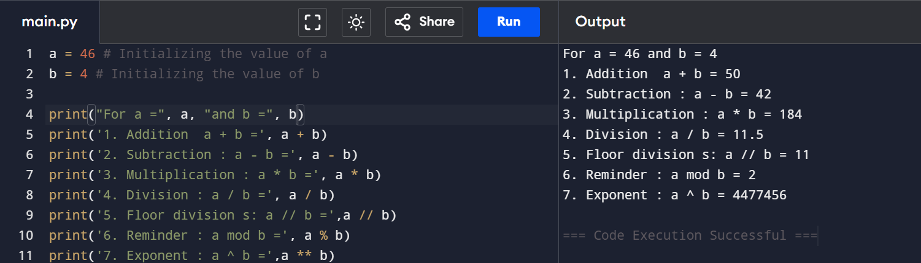

**Comparison Operators**

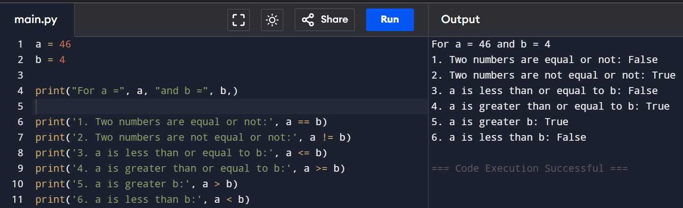

**Assignment Operators**

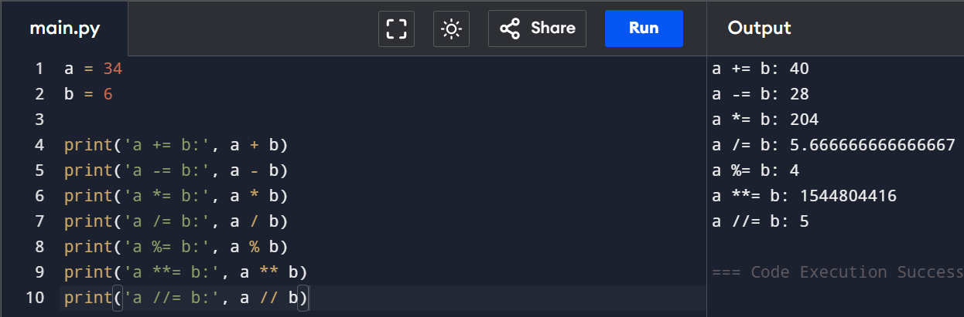

**Bitwise Operators**

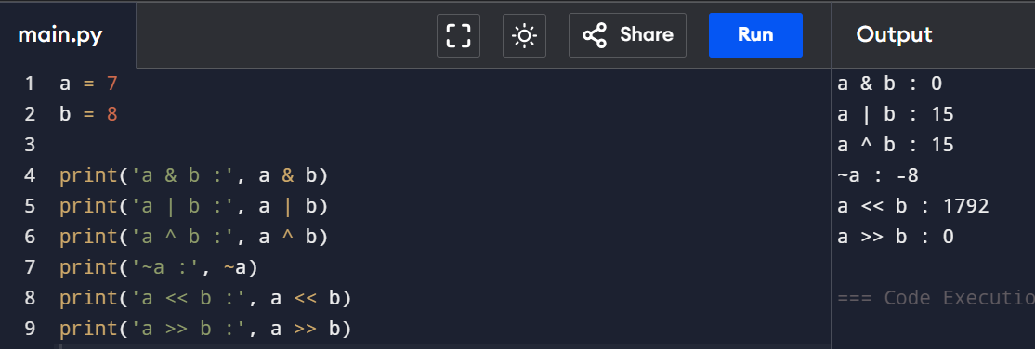

**Logical Operators**

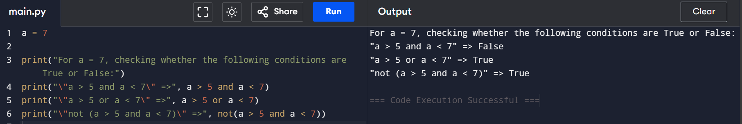

**Membership Operators**

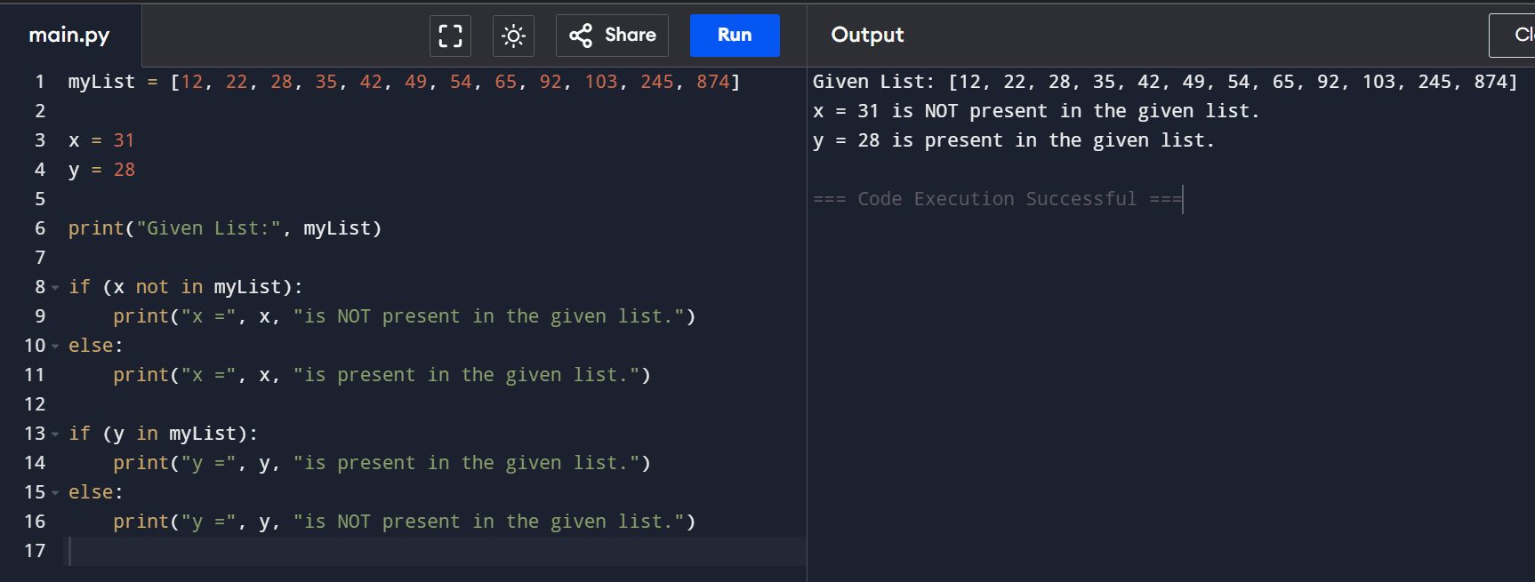

**Identity Operators**

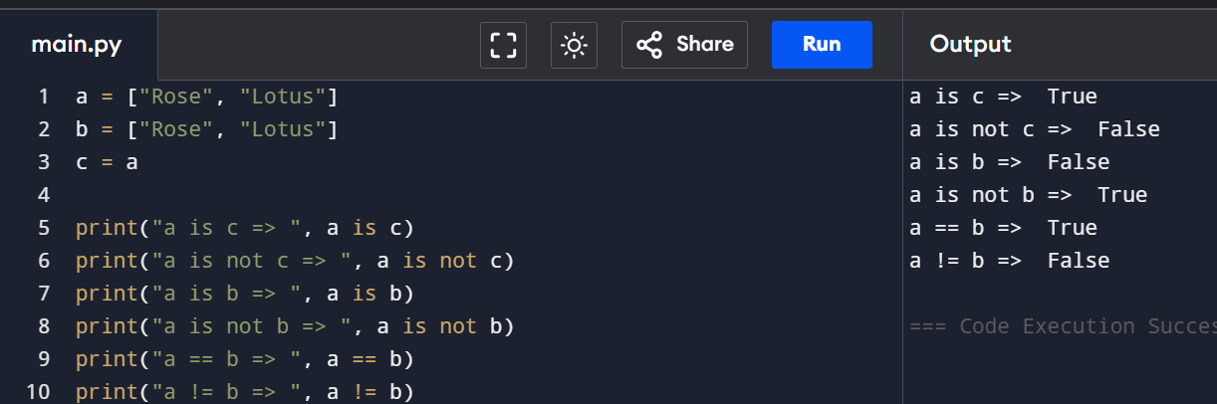

**How to reverse a string in Python?**

1. Using for loop

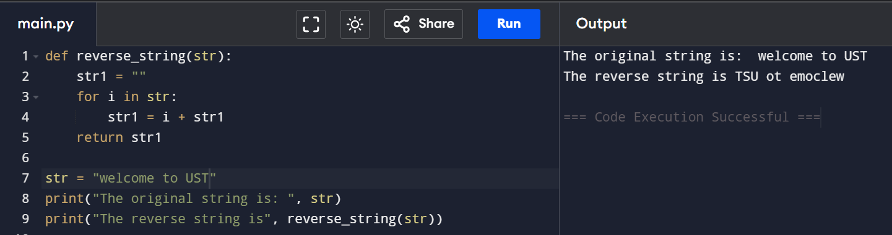

1. Using while loop

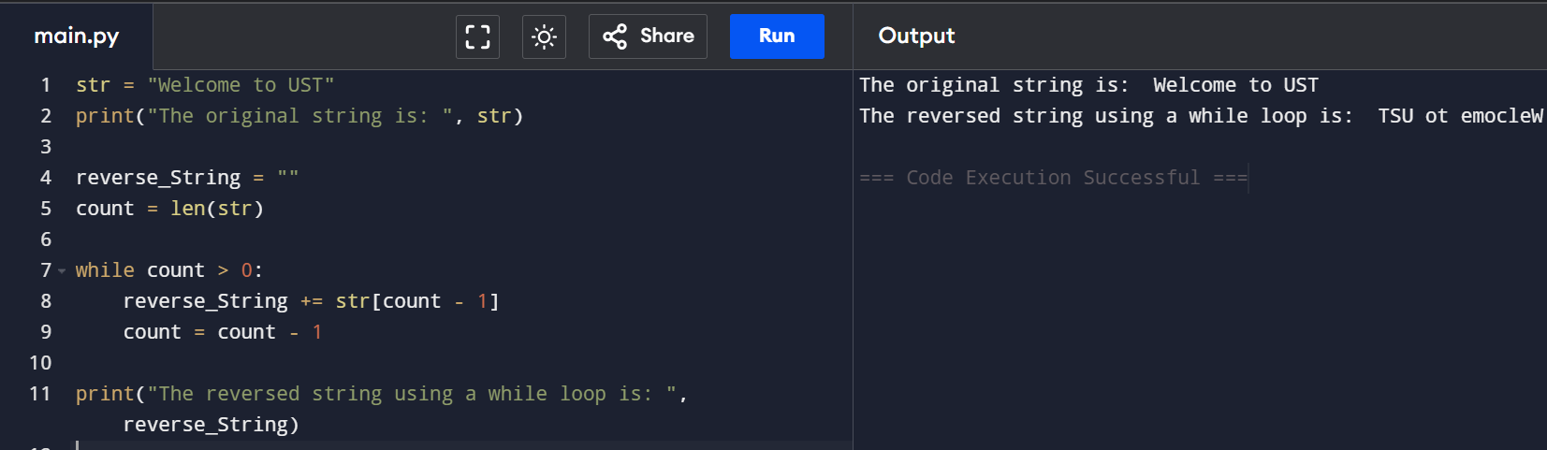

1. Using the slice operator

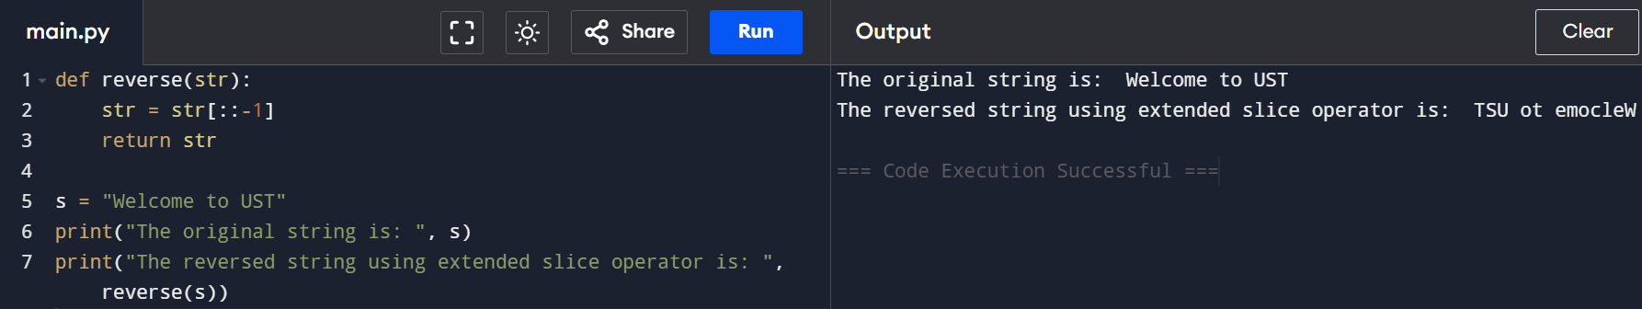

1. Using the reversed() function

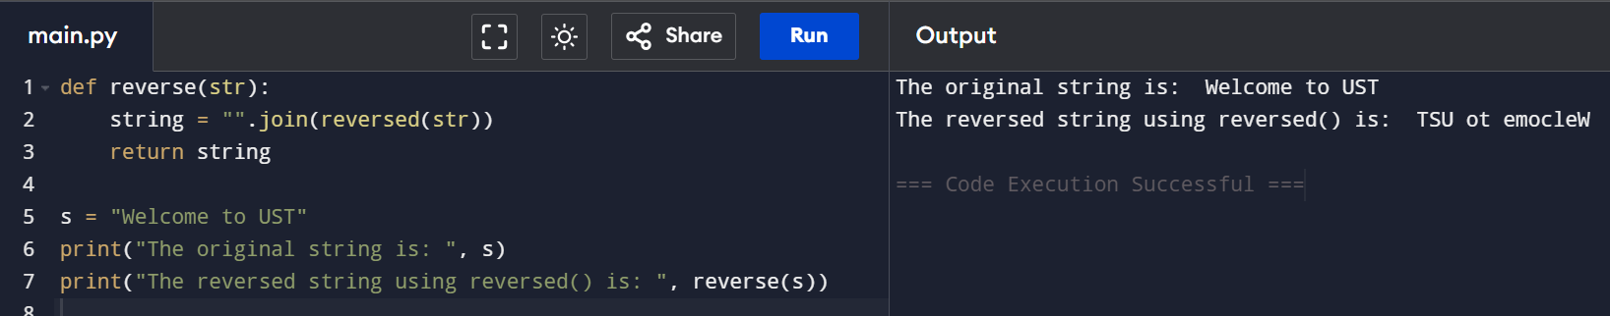

1. Using the recursion

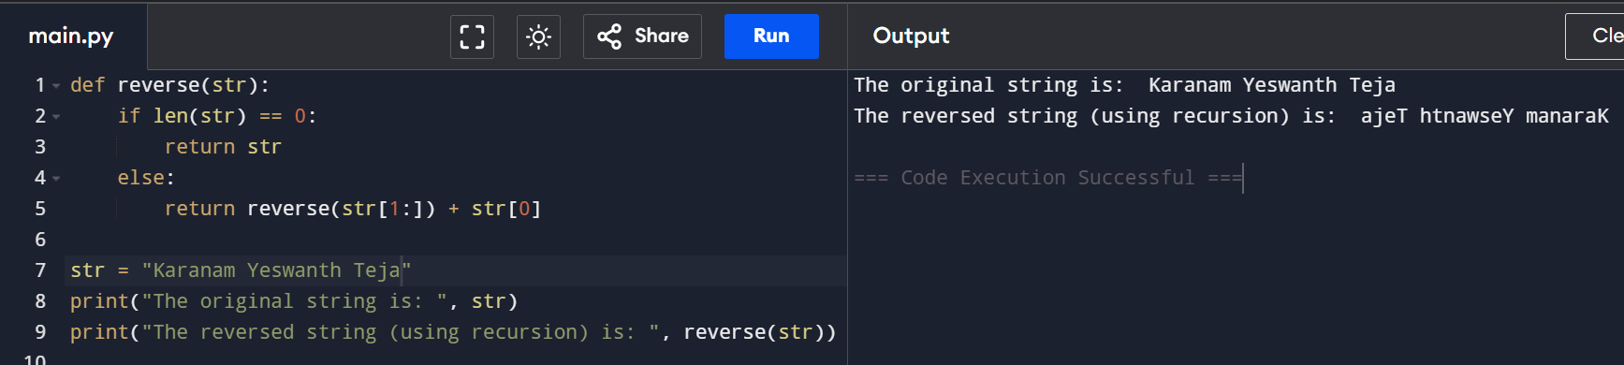

How to read CSV file in Python?

